- Write a Python program to Demonstrate how to Draw a Bar Plot using Matplotlib.

import matplotlib.pyplot as plt

# Sample data for demonstration
categories = ['0-10', '10-20', '20-30', '30-40', '40-50']
values = [55, 48, 25, 68, 90]

# Create a bar plot
plt.bar(categories, values, color='skyblue')

# Add labels and title
plt.xlabel('Overs')
plt.ylabel('Runs')
plt.title('Bar Plot Showing Runs scored in an ODI Match')

# Display the plot
plt.show()

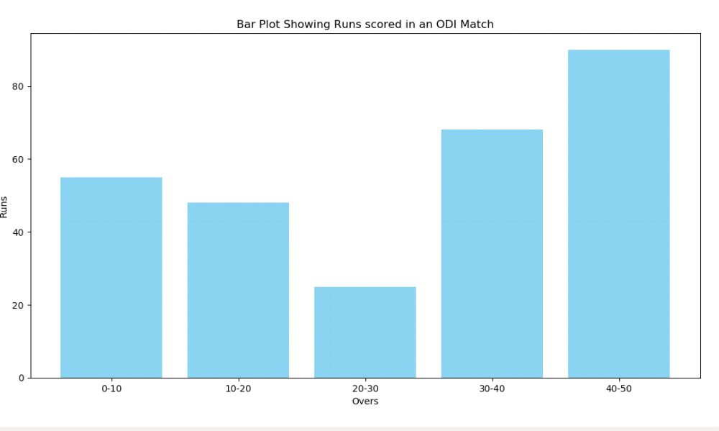

B)Write a Python program to Demonstrate how to Draw a Scatter Plot using Matplotlib.

import matplotlib.pyplot as plt
import numpy as np

# BRICS nations data (hypothetical)
countries = ['Brazil', 'Russia', 'India', 'China', 'South Africa']
population = [213993437, 145912025, 1393409038, 1444216107, 61608912] # Population in 2021
per_capita_income = [9600, 11600, 2300, 11000, 6500] # Per capita income in USD

# Scale the population for circle size
circle_size = [pop / 1000000 for pop in population] # Scaling down for better visualization

# Assign different colors based on index
colors = np.arange(len(countries))

# Create a scatter plot with varying circle sizes and colors
scatter = plt.scatter(population, per_capita_income, s=circle_size, c=colors, cmap='viridis', alpha=0.7, label='BRICS Nations')

# Annotate each point with the country name
for i, country in enumerate(countries):
plt.annotate(country, (population[i], per_capita_income[i]), textcoords="offset points", xytext=(0,5), ha='center')

# Add colorbar
plt.colorbar(scatter, label='Index')

# Add labels and title
plt.xlabel('Population')
plt.ylabel('Per Capita Income (USD)')
plt.title('Population vs Per Capita Income of BRICS Nations')

# Display the plot
plt.show()

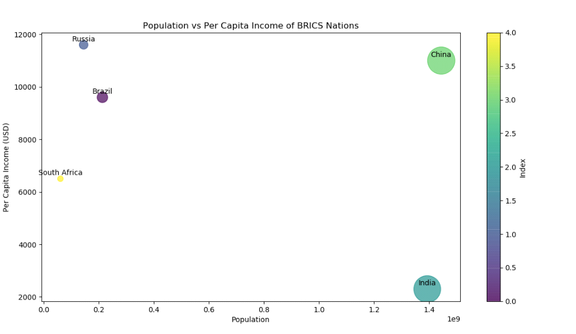

- Write a Python program to Demonstrate how to Draw a Histogram Plot using Matplotlib.

import matplotlib.pyplot as plt
import numpy as np

# Generate random student scores (example data)
np.random.seed(42)
student_scores = np.random.normal(loc=70, scale=15, size=100)

# Create a histogram plot
plt.hist(student_scores, bins=20, color='skyblue', edgecolor='black')

# Add labels and title
plt.xlabel('Student Scores')
plt.ylabel('Frequency')
plt.title('Distribution of Student Scores')

# Display the plot
plt.show()

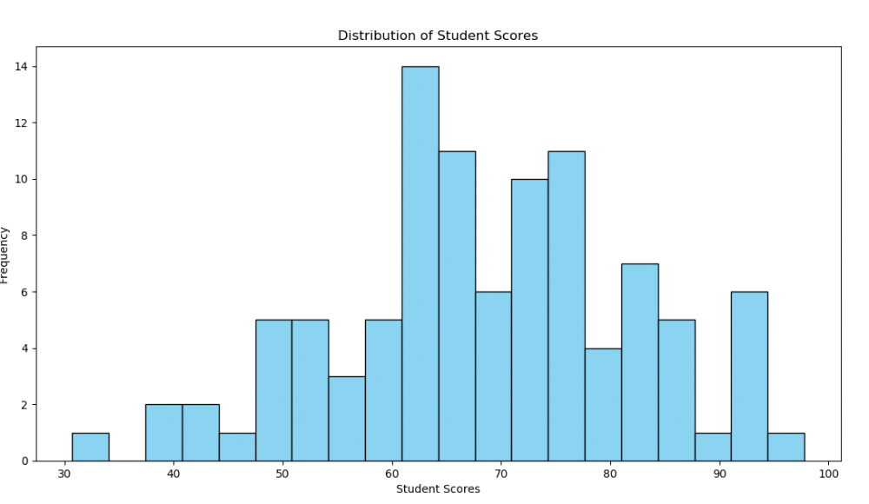

B)Write a Python program to Demonstrate how to Draw a Pie Chart using Matplotlib.

import matplotlib.pyplot as plt

#Number of FIFA World Cup wins for different countries
countries = ['Brazil', 'Germany', 'Italy', 'Argentina', 'Uruguay', 'France', 'England', 'Spain']
wins = [5, 4, 4, 3, 2, 2, 1, 1] # Replace with actual data

# Colors for each country
colors = ['yellow', 'magenta', 'green', 'blue', 'lightblue', 'blue', 'red', 'cyan']

plt.pie(wins, labels=countries, autopct='%1.1f%%', colors=colors, startangle=90, explode=[0.2, 0.2, 0.2, 0.2, 0.2, 0.2, 0.2, 0.2], shadow=True)

# Add title
plt.title('FIFA World Cup Wins by Country')

# Display the plot
plt.axis('equal') # Equal aspect ratio ensures that the pie chart is circular.
plt.show()

